Regulatory Committee
Meeting to be held on 17th November 2021

Part I

Electoral Division affected:
Heysham

Wildlife and Countryside Act 1981
Definitive Map Modification Order Investigation
Investigation into Public Rights on Moss Lane, Overton
(Annex ‘A’ refers)

Contact for further information:
Simon Moore, 01772 531280, Paralegal Officer, County Secretary and Solicitors Group, Simon.Moore@lancashire.gov.uk
Jayne Elliott, 01772 537663, Public Rights of Way Definitive Map Officer, Planning and Environment Group, jayne.elliott@lancashire.gov.uk

Brief Summary

Investigation into the Public Rights on Footpath Overton 1 – known as Moss Lane - following an application to upgrade it to Bridleway.

Recommendation

That the application for the route recorded as Footpath Overton 1 (Moss

Lane) to be recorded on the Definitive Map and Statement of Public Rights of Way as a Bridleway, be accepted subject to carriageway rights also being recognised.

That an Order be made pursuant to Section 53 (2)(b) and Section 53 (3)(c)(ii)

of the Wildlife and Countryside Act 1981 to upgrade Overton 1 (Moss Lane) from Footpath to Restricted Byway on the Definitive Map and Statement of Public Rights of Way.

That being satisfied that the test for confirmation can be met the Order be

promoted to confirmation.

Details

An application under Schedule 14 of the Wildlife and Countryside Act 1981 has been received for Footpath Overton 1 to be upgraded to Bridleway on the Definitive Map and Statement of Public Rights of Way.

The county council is required by law to investigate the evidence and make a decision based on that evidence as to whether a public right of way exists, and if so its status. Section 53(3)(b) and (c) of the Wildlife and Countryside Act 1981 set out the tests that need to be met when reaching a decision; also current Case Law needs to be applied.

An order for upgrading or downgrading a way shown on the Definitive Map and Statement will only be made if the evidence shows that:
- "it ought to be there shown as a highway of a different description"

An order for adding a way to or upgrading a way shown on the Definitive Map and Statement will be made if the evidence shows that:
- “the expiration… of any period such that the enjoyment by the public…raises a presumption that the way has been dedicated as a public path or restricted byway”

When considering evidence, if it is shown that a highway existed then highway rights continue to exist (“once a highway, always a highway”) even if a route has since become disused or obstructed unless a legal order stopping up or diverting the rights has been made. Section 53 of the Wildlife and Countryside Act 1981 makes it clear that considerations such as suitability, the security of properties and the wishes of adjacent landowners cannot be considered. The Planning Inspectorate’s website also gives guidance about the interpretation of evidence.

The county council’s decision will be based on the interpretation of the evidence discovered by officers and documents and other evidence supplied by the applicant, landowners, consultees and other interested parties produced to the County Council before the date of the decision. Each piece of evidence will be tested and the evidence overall weighed on the balance of probabilities. It is possible that the council’s decision may be different from the status given in any original application. The decision may be that the routes have public rights as a footpath, bridleway, restricted byway or byway open to all traffic, or that no such right of way exists. The decision may also be that the routes to be added or deleted vary in length or location from those that were originally considered.

Consultations

Lancaster City Council
Lancaster City Council did not respond to consultation.

Overton Parish Council

Overton Parish Council responded to our consultation with an objection to the application.

The grounds for opposing the application were stated as:
1. The fields traversed by Footpath Overton 1 are primarily used for grazing, horse traffic will disturb grazing livestock.
2. Horses will trample the surface of Footpath Overton 1 to the detriment of other users.
3. The exit from Footpath Overton 1 onto Downeyfield Road is at a dangerous bend. Currently the exit to Downeyfield Road is via a stile which discourages rapid exit. Upgrading to a bridleway will involve the provision of a gated exit/entrance with the risk of horses waiting on the carriageway and the risk of livestock escaping if the gate is left open.
4. Walkers and riders will use the gate and there is a risk of livestock escaping onto the road at this dangerous location.

Applicant/Landowners/Supporters/Objectors

The evidence submitted by the applicant/landowners/supporters/objectors and observations on those comments are included in Advice – Head of Service – Legal and Democratic Services Observations.

Advice

Head of Service – Planning and Environment

Points annotated on the attached Committee plan.

Point | Grid Reference (SD) | Description
A | 4316 5912 | Junction with Downeyfield Road immediately to the east of Downeyfield Bridge
B | 4321 5892 | Route crossed by a wooden stile and metal field gate
C | 4325 5875 | Bend in the stream and path
D | 4345 5844 | Route crossed by a wooden field gate and stile
E | 4349 5838 | Route crossed by a metal field gate
F | 4351 5833 | Open junction with Middleton Road immediately east of Middlepool Bridge

Description of Route

A site inspection was carried out in October 2020.

The route commences at a point on Downeyfield Road immediately to the east of Downeyfield Bridge (point A on the Committee plan). Immediately adjacent to the end of the stone abutment of the bridge is a wooden stile and large metal double field gates which were locked and blocked by a large boulder at the time of inspection.

From point A the route extends in a south south easterly direction along the edge of a pasture field with a wooden post and wire fence along the west side which encloses Lades Pool stream.

At point B the route is crossed by a further metal gate with a wooden stile alongside it. The route continues in a south south easterly direction following the fence along the west boundary of the field.

Between point B and point C there are some signs of what appears to have been an old hedge-line along the stream edge and some raised sections of land in the field immediately to the east of the route which give the impression that the route had, at some point in the past, been separate from the field.

At point C, near the parish boundary between Overton and Heaton with Oxcliffe, the stream – and path – turn to continue in a more south easterly direction.

From point C to point D the route follows the edge of the field with further evidence of old hedges which appear to have largely been removed. Where the stream bends away from the route there is a wooden post and wire fence running along the west side of the route and as the stream bends round to continue once more along the side of the route the route itself becomes enclosed on either side by hedges for parts of the length as it approaches point D.

At point D the route is crossed by a further wooden field gate and stile beyond which a stone surface track is enclosed between hedges and fencing with a small sheep-handling unit constructed along the side of the lane. The route continues to point E as a stone surfaced track separate from the adjacent fields to point E where there is a large metal field gate (open on the day that the route was inspected).

Beyond point E the route is open and forms the access to two residential properties and farmland. This section has been tarmacked but is in poor repair. At point F the route meets Middleton Road at an open junction immediately east of Middlepool Bridge.

The total length of the route is 880 metres. It is recorded as a public footpath and is currently signed as such at point A and point F.

Map and Documentary Evidence

A variety of maps, plans and other documents were examined to discover when the route came into being, and to try to determine what its status may be.

Document Title | Date | Brief Description of Document & Nature of Evidence
Yates’ Map  of Lancashire | 1786 | Small scale commercial map. Such maps were on sale to the public and hence to be of use to their customers the routes shown had to be available for the public to use. However, they were privately produced without a known system of consultation or checking. Limitations of scale also limited the routes that could be shown.
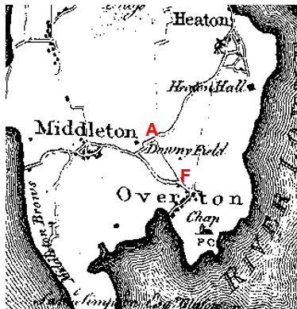
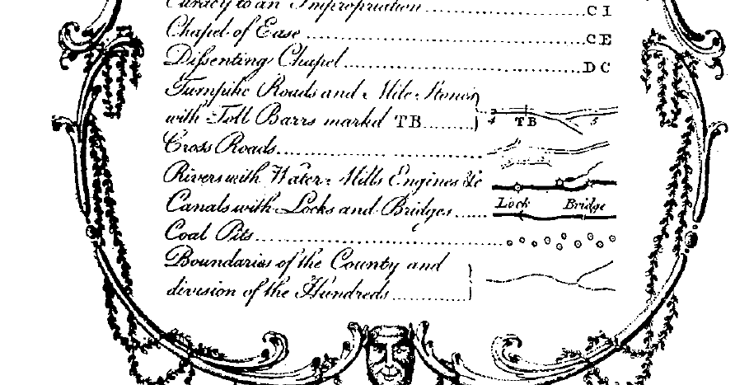
Observations |  | The full length of the application route is shown as a cross road linking to two roads now recorded as public vehicular highways. The quality of the map extract when enlarged is quite faint but close examination does show that the route is shown with lines along either side consistent with how a cross road is shown on the map.
Investigating Officer's Comments |  | The application route existed in 1786 and was shown as a cross road. It is not known what is meant by the term 'cross road' but the only other category of highway shown on the map is turnpike roads. This small scale map only appeared to show the more significant routes and did not generally show routes currently recorded as public footpaths. This suggests that the route was of a substantial nature and would have been capable of being used by people on horseback and possibly with horse drawn vehicles as a through-route at that time.
Greenwood’s Map of Lancashire | 1818 | Small scale commercial map. In contrast to other map makers of the era Greenwood stated in the legend that this map showed private as well as public roads and the two were not differentiated between within the key panel.
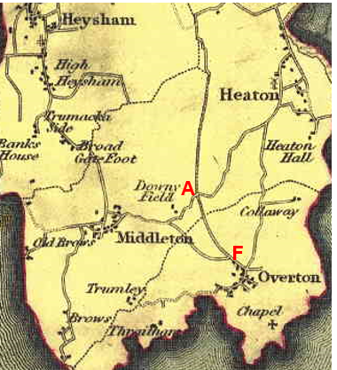
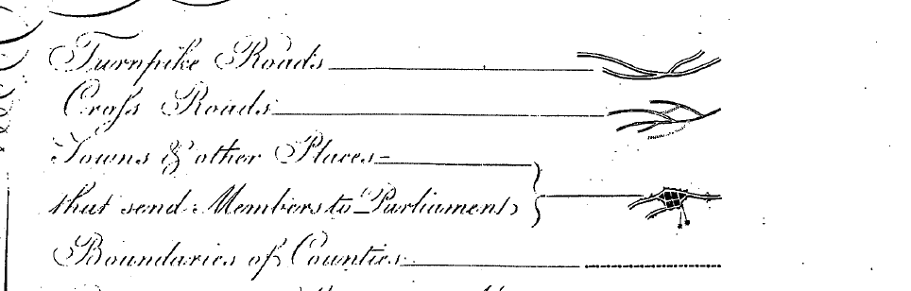
Observations |  | The application route is clearly shown as a through route linking to other routes now recorded as public vehicular highways. It is shown on the map as a cross road.
Investigating Officer's Comments |  | The application route existed as a substantial route in 1818 forming part of a direct link to the village of Overton. The inclusion of the route on a small scale commercially produced map of this kind is suggestive of the fact that the route is likely to have been considered to have been a public carriageway or at least a bridleway. It is unlikely that a map of this scale would show footpaths. It is not known what Greenwood meant by the term 'cross road' but he only categorised roads as 'cross roads' and 'turnpike roads' according to the key to his map.
Hennet's Map of Lancashire | 1830 | Small scale commercial map. In 1830 Henry Teesdale of London published George Hennet's Map of Lancashire surveyed in 1828-1829 at a scale of 71/2 inches to 1 mile. Hennet's finer hachuring was no more successful than Greenwood's in portraying Lancashire's hills and valleys but his mapping of the county's communications network was generally considered to be the clearest and most helpful that had yet been achieved.
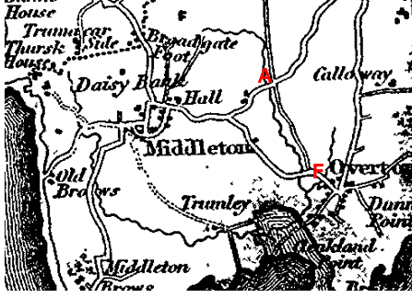
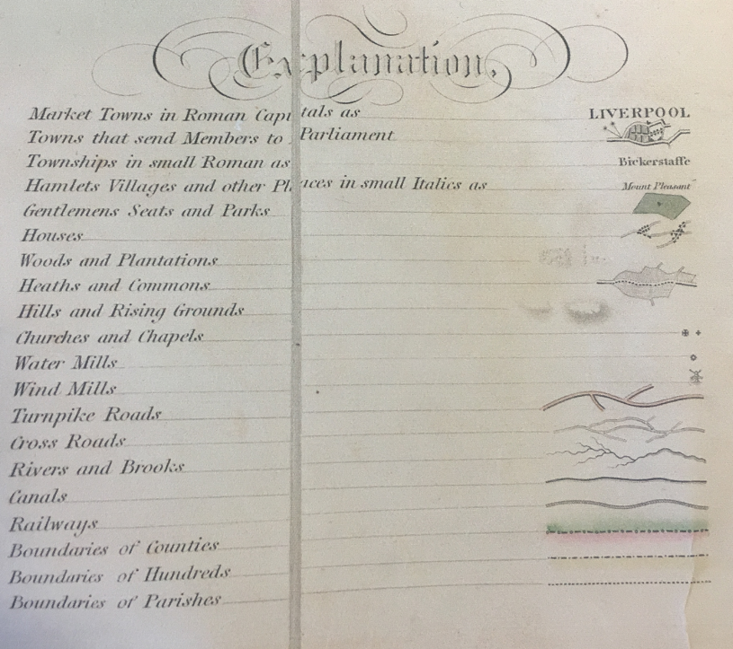
Observations |  | The full length of the application route is shown but it is shown to be noticeably narrower than the public vehicular routes to which it connects and there appears to be a line across the end of the route at point F. The key to the map indicates that routes shown were either turnpike roads or cross roads and in this instance it appears that the application route was shown as a cross road.
Investigating Officer's Comments |  | The application route existed in 1830 as a significant route and it is unlikely that a map of this scale would show footpaths.  It is not fully known what is meant by this term. As the only other category of 'road' shown on the map are turnpike roads, it is possible that a cross road was regarded as either a public minor cart road or a bridleway (as suggested by the judge in Hollins v Oldham).  Hollins v Oldham Manchester High Court (1995) [C94/0205] Judge Howarth examined various maps from 1777-1830 including Greenwood's, Bryant's and Burdett's maps of this type, which showed cross roads and turnpikes, were maps for the benefit of wealthy people and were very expensive. There was “no point showing a road to a purchaser if he did not have the right to use it.”  The route is shown as a through route on this and other small scale commercial maps but these maps do not show width variations so the fact that the route is shown to be narrower than other routes to which it connects cannot be taken, on its own, as a clear indication as to its width. Better detail of widths and existence of gates for example is not available until the route is considered on maps produced at higher scale.  The way the route is shown may however indicate that by the 1830s the better used – or more suitable – route for horse drawn vehicles was looping west via Downeyfield Road and Middleton Road.
Canal and Railway Acts |  | Canals and railways were the vital infrastructure for a modernising economy and hence, like motorways and high speed rail links today, legislation enabled these to be built by compulsion where agreement couldn't be reached. It was important to get the details right by making provision for any public rights of way to avoid objections but not to provide expensive crossings unless they really were public rights of way. This information is also often available for proposed canals and railways which were never built.
Observations |  | The application route does not cross land affected by the construction of any railways or canals and there are no known proposals to construct either in the past.
Investigating Officer's Comments |  | No inference can be drawn with regards to the existence of public rights.
Tithe Map and Tithe Award or Apportionment  Overton Tithe Map and Award 1844  Middleton Tithe Map 1844  Heaton with Oxcliffe Tithe Map 1841 | 1841 - 1844 | Maps and other documents were produced under the Tithe Commutation Act of 1836 to record land capable of producing a crop and what each landowner should pay in lieu of tithes to the church. The maps are usually detailed large scale maps of a parish and while they were not produced specifically to show roads or public rights of way, the maps do show roads quite accurately and can provide useful supporting evidence (in conjunction with the written tithe award) and additional information from which the status of ways may be inferred.
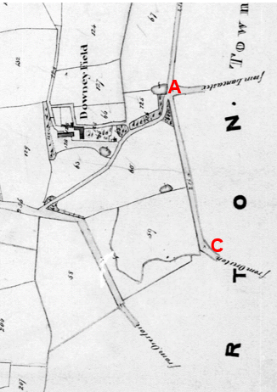
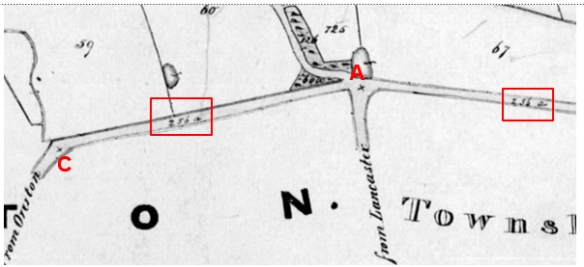
Extracts from the Tithe Map for Middleton 1844
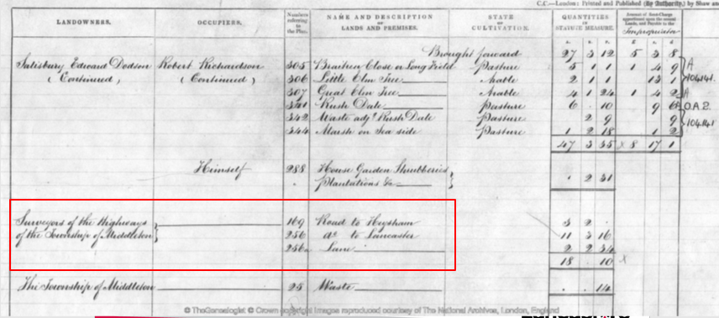
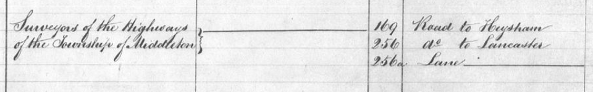
Extracts from Middleton Tithe Award
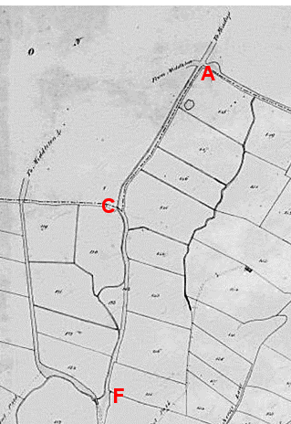
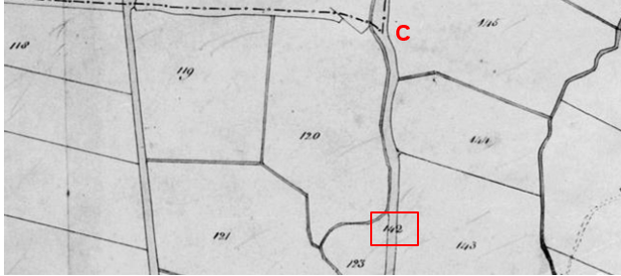
Extracts from the Tithe Map for Overton 1844
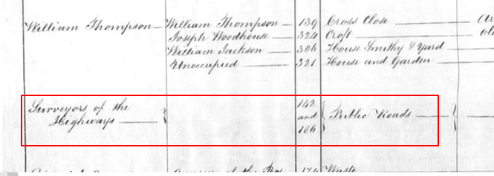
Extract from theTithe Award for Overton 1844
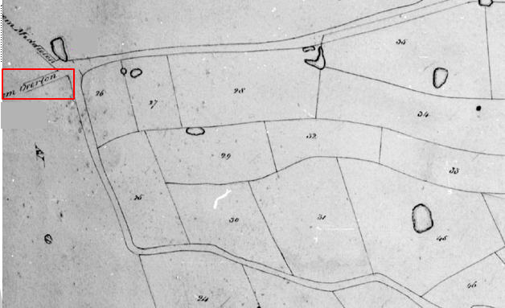
Extract from Tithe Map for Heaton with Oxcliffe 1841
Observations |  | The full length of the application route is shown on the Tithe Map for Overton 1844 and is numbered as plot 142. The Tithe Award lists plot 142 as being owned by the Surveyors of the Highways and lists the route as a public road.  Significantly Point A is a junction of a number of routes with the continuations labelled “From Middleton”, “To Meadup” and “To Lancaster”.  In addition, on the Middleton Tithe Map 1844 the northern section of the application route between point A and point C is shown as Plot 256a and listed in the Apportionment as owned by the Surveyors of the Highways and described as a 'lane'. It is labelled “from Overton.  Finally, on the Heaton with Oxcliffe Tithe Map, prepared several years earlier in 1841, the start of the route at point A is shown and is labelled “from Overton”.
Investigating Officer's Comments |  | A substantial bounded route physically existed that would probably be wide enough for vehicles (carts) in the 1840s and which was regarded as a public road through Overton in 1844.  It is not shown as being gated suggesting access was freely available along the full length.  It is rare to find evidence of a route on three separate Tithe Maps but in this case we not only have reference to the existence of the route on three maps but we also have a consistent view of the fact that it was considered to be a public road in the early 1840s.
Inclosure Act Award and Maps |  | Inclosure awards are legal documents made under private acts of Parliament or general acts (post 1801) for reforming medieval farming practices, and also enabled new rights of way layouts in a parish to be made. They can provide conclusive evidence of status.
Observations |  | No inclosure award was found for the area crossed by the application route.
Investigating Officer's Comments |  | No inference can be drawn.
6 Inch Ordnance Survey (OS) Map  Sheet 34 | 1848 | The earliest Ordnance Survey 6 inch map for this area surveyed in 1844-45 and published in 1848.
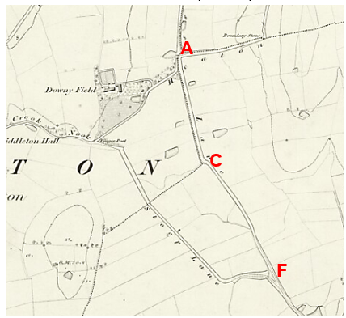
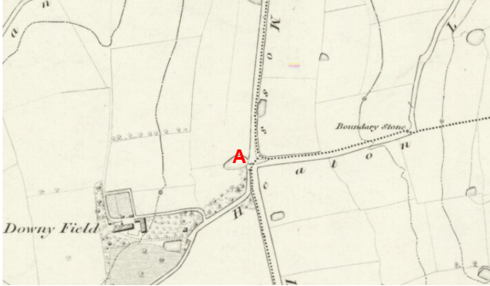
Observations |  | The whole length of the route is shown as part of a longer through-route. No barriers are shown across the route suggesting that it was ungated and access unrestricted. The full length of the application route is shown as an enclosed route connecting to other routes now recorded as public vehicular highways. The route – and the continuation of a route north of point A - are labelled on the map as 'Moss Lane'.
Investigating Officer's Comments |  | The full length of the application route existed and appeared to be capable of being used in 1848. Its shared name suggested it was contiguous with the road to the north of point A.  It is considered that a substantial bounded route connecting to a network of other public highways would have been at least a public bridleway and probably carried public vehicular rights.
25 Inch OS Map  Sheet 34.1 | 1891 | The earliest OS map at a scale of 25 inch to the mile. Surveyed in 1890 and published in 1891.
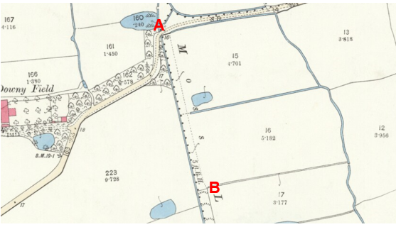
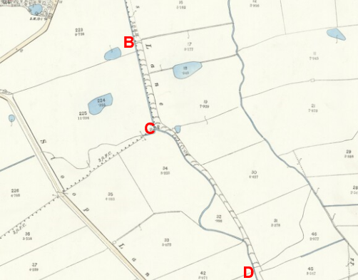
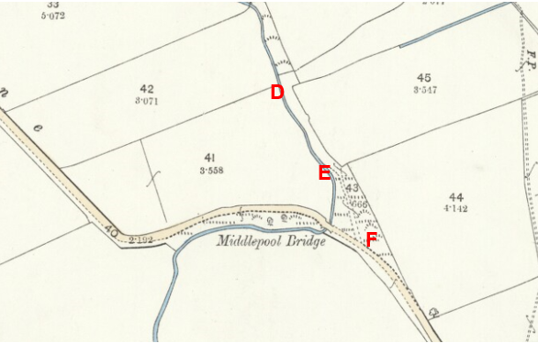
Observations |  | The full length of the application route is shown. It is labelled as being called Moss Lane but appears to be less significant than on earlier maps examined. The route appears to be gated at point A and at point B and between these two points the route is shown fenced off from the watercourse but as part of the fields numbered as plots 15 and 16. Beyond point B the route still appears to be bounded on both sides but the map shows that the surface of the route from point B through to point D was considered to be rough pasture. A further gate is shown close to point D beyond which the route continues between fences and numbered as parcel 43 through another area marked as rough pasture to point F.  Downeyfield Road and Middleton Road (Stoop Lane) are both shown coloured on the map with a thickened line along the south and east side but the application route is not shown in this way.
Investigating Officer's Comments |  | The application route still existed in 1890 but use appeared to have declined as indicated by the fact that the surface was shown as rough pasture – probably indicating that it was wet and boggy and no longer easy to use with vehicles or possibly even on horseback.  The fact that it was still named as a lane on the map is evidence that even if use had declined it was still known locally by that name.  The fact that the route is now shown gated and not separated from the adjacent fields between point A and point B also suggests that public use may have declined. However the existence of gates along a public route would not have been considered unusual in the 1800s particularly in the proximity of farms or in rural locations. Gateways, if they were found to exist, were shown by the surveyor in their closed position although this is not necessarily a true reflection of what may have been the position on the ground.  Shading and colouring were often used to show the administrative status of roads on 25 inch maps prepared between 1884 and 1912. The Ordnance Survey specified that all metalled public roads for wheeled traffic kept in good repair by the highway authority were to be shaded and shown with thickened lines on the south and east sides of the road. ‘Good repair’ meant that it should be possible to drive carriages and light carts over then at a trot so the fact that the route is not shown in this way suggests that by the late 1800s use of the route – which had previously been recorded on the Tithe Map and Award as a public road and shown on early small scale commercial maps – had declined.
6 inch OS  Sheet 34 | 1895 | 6 inch OS map surveyed 1890 and published 1895.
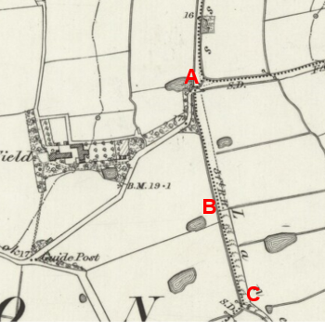
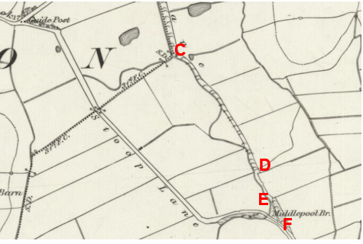
Observations |  | The full length of the application route is shown in the same way as it is shown on the 25 inch OS map published four years earlier and both maps had a survey date of 1890 suggesting that they were compiled from the same survey.
Investigating Officer's Comments |  | The application route existed in 1890 and appeared to be capable of being used on foot and possibly horseback. Use by vehicles appears to have declined and may now have been too difficult with public vehicular traffic travelling along Downey Field Road west from point A to the Guide Post at the junction with Stoop Lane (Overton Road) to point F.
1 inch OS Map  Sheet 59 Lancaster | 1898 | Small scale OS map revised 1896 and published 1898.
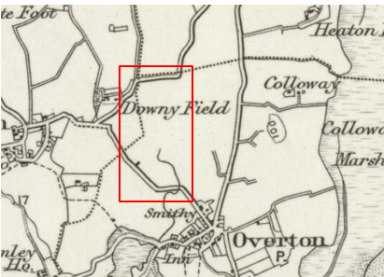
Observations |  | The application route is not shown.
Investigating Officer's Comments |  | The original scale of the map (1 inch to the mile) means that only the more significant routes are generally shown. The purpose of the map in the late 1800s would probably have been to assist the travelling public on horseback or vehicle suggesting that the through roads shown had public rights for those travellers. The fact that the application route is not shown suggests that it was no longer suitable for vehicular use and/or that it was not considered to be a public vehicular route at that time.  The fact that the route is not shown is not inconsistent with the existence of routes which were used on foot or possibly on horseback at that time.
25 inch OS Map  Sheet 34.1 | 1913 | Further edition of the 25 inch map surveyed in 1890, revised in 1910 and published in 1913.
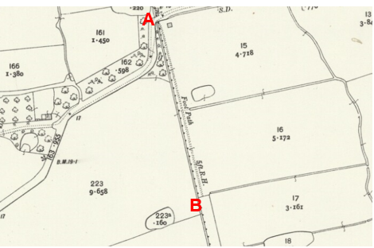
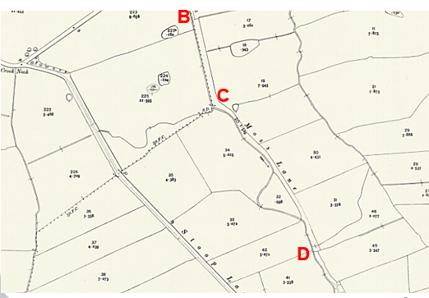
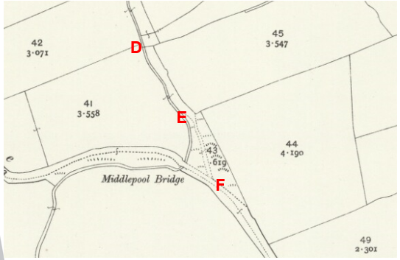
Observations |  | The full length of the application route is shown. The route is again shown to be gated at point a and point B and between these two points the route is labelled with the word 'footpath'.  Between point B and a further gate at point D the route is shown enclosed and is labelled as 'Moss Lane'. Between point D and point E the route is shown as a track passing through an area of rough land but is open and not gated.
Investigating Officer's Comments |  | The application route existed in 1910 and appears to have altered very little since the earlier 25 inch map was produced. The only significant difference is the labelling of the route between point A and point B as a footpath. This gives an indication as to the routes physical appearance as it appeared to the surveyor at that time and suggests that a trodden track may have existed along this section which was indicative of use of the route on foot. Again, the way that the route is shown on the map suggests that use of the route with vehicles – and possibly on horseback had declined or possibly stopped altogether.
Bartholomew half inch Mapping | 1902-1906 | The publication of Bartholomew's half inch maps for England and Wales began in 1897 and continued with periodic revisions until 1975. The maps were very popular with the public and sold in their millions, due largely to their accurate road classification and the use of layer colouring to depict contours. The maps were produced primarily for the purpose of driving and cycling and the firm was in competition with the Ordnance Survey, from whose maps Bartholomew's were reduced. An unpublished Ordnance Survey report dated 1914 acknowledged that the road classification on the OS small scale map was inferior to Bartholomew at that time for the use of motorists.
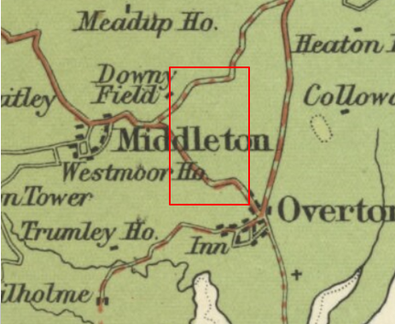
1905
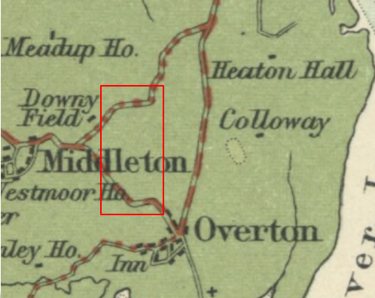
1920
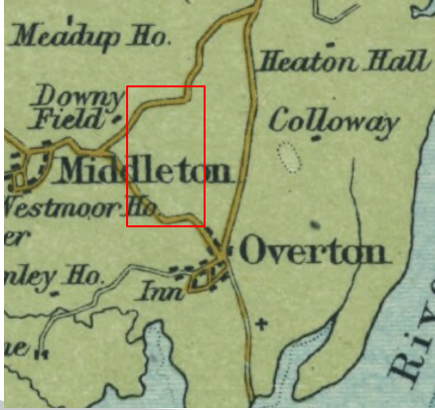
1941
Observations |  | The application route is not shown on any of the three maps published by Bartholomew between 1905 and 1941.
Investigating Officer's Comments |  | The fact that the application route is not shown on the maps suggests that it was not usable as a public vehicular highway in the early 1900s. The route does not generally show routes used as footpaths or bridleways at that time.
Finance Act 1910 Map | 1910 | The comprehensive survey carried out for the Finance Act 1910, later repealed, was for the purposes of land valuation not recording public rights of way but can often provide very good evidence. Making a false claim for a deduction was an offence although a deduction did not have to be claimed so although there was a financial incentive a public right of way did not have to be admitted.  Maps, valuation books and field books produced under the requirements of the 1910 Finance Act have been examined. The Act required all land in private ownership to be recorded so that it could be valued and the owner taxed on any incremental value if the land was subsequently sold. The maps show land divided into parcels on which tax was levied, and accompanying valuation books provide details of the value of each parcel of land, along with the name of the owner and tenant (where applicable).  An owner of land could claim a reduction in tax if his land was crossed by a public right of way and this can be found in the relevant valuation book. However, the exact route of the right of way was not recorded in the book or on the accompanying map. Where only one path was shown by the Ordnance Survey through the landholding, it is likely that the path shown is the one referred to, but we cannot be certain. In the case where many paths are shown, it is not possible to know which path or paths the valuation book entry refers to. It should also be noted that if no reduction was claimed this does not necessarily mean that no right of way existed.
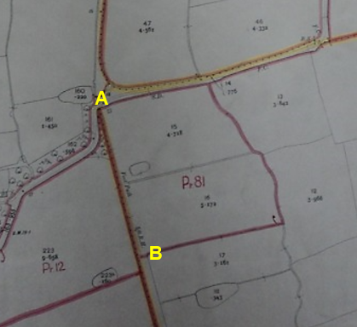
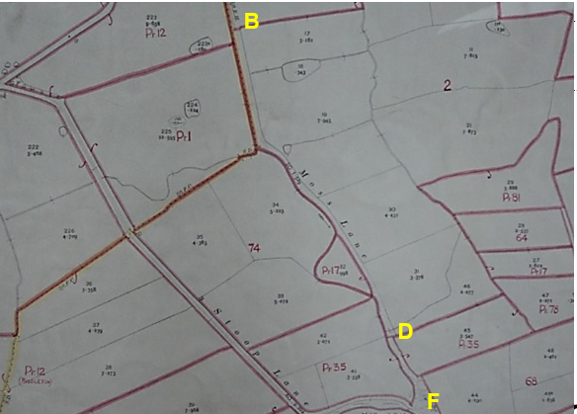
Observations |  | Between A and point B the land crossed by the application route is included in the numbered plot 81. The District Valuation book lists this plot as being owned by James Curwell and occupied by James Gardner. It was described as 'land' and no deductions were claimed for public rights of way or user.  Between point B and point D the land crossed by the application route is included in plot 2 which is listed as being owned by Thomas Ireland and occupied by Samuel Jackson. It was described as 'land' and no deductions were recorded for public rights of way or user.  From point D to point F the route is excluded from the numbered plots.
Investigating Officer's Comments |  | It appears that the owners of the land crossed by the application route between point A and point D did not acknowledge the existence of any public rights over the land crossed by the application route at the time of the valuation.  Between point D and point F the application route was physically separated from the adjacent land in the early 1900s and although the exclusion of a route from the numbered hereditaments (plots) is often considered to be good evidence of the fact that a route was believed to carry public vehicular rights it is noted that the rest of the route was not shown in this way so this view must be weighed up in relation to all available evidence and on balance it appears that the route was not considered to be a public vehicular through route in the early 1900s.
6 inch OS  Sheet 34 NW | 1916 | 6 inch OS surveyed 1845, revised 1910 and published 1916
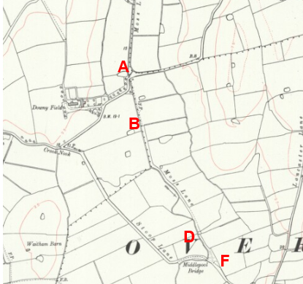
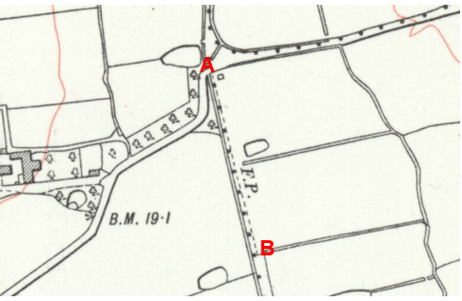
Observations |  | This further edition of the 6 inch OS map shows the full length of the application route in the same way that it is shown on the 25 inch OS map published in 1913. Both maps were prepared following a survey in 1910 so it is not surprising that they show the route in the same way.
Investigating Officer's Comments |  | The application route existed in 1910 and appears to have altered very little since the 1890s. The only significant difference is the labelling of the route between point A and point B as a footpath suggests that a trodden track may have existed along this section which was indicative of use of the route on foot. The way that the route is shown on the map suggests that use of the route with vehicles – and possibly on horseback - had declined or possibly stopped altogether.
1 inch OS Map | 1918 | Map extract submitted by applicant and published 1918. Date of survey not known.
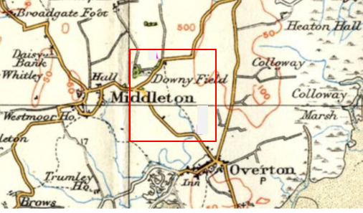
Observations |  | The application route is shown as a single dashed line in the same way as other routes in the area which are now recorded as footpaths.
Investigating Officer's Comments |  | The application existed in 1918 and appeared to be capable of being used, at least on foot.
1932 Rights of Way Map |  | The Rights of Way Act 1932 set out the mechanism by which public rights of way could be established by user and under which landowners could deposit maps to show highways already in existence and to indicate that they didn't intend to dedicate further rights of way. The Commons, Open Spaces and Footpath Preservation Society (which became the Open Spaces Society) who were the prime instigators of this Act and the later 1949 Act, called for local authorities to draw up maps of the public rights of way in existence (a quasi pre-cursor of the Definitive Map). This is set out in 'The Rights of Way Act, 1932. Its History and meaning' by Sir Lawrence Chubb [M]. The process for consultation and scrutiny followed in Lancashire is not recorded but some of the maps exist including maps for the following areas are available for inspection at County Hall: Lunesdale Rural District (RD), Lancaster RD, Burnley RD, Garstang RD and West Lancashire RD.
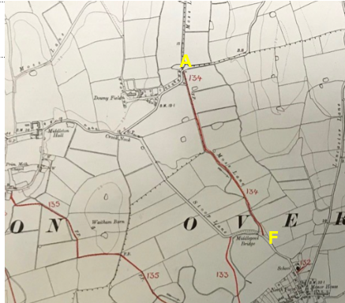
Observations |  | The application route is recorded as a footpath on the map prepared by Lancaster Rural District.
Investigating Officer's Comments |  | The application route was considered to be a public footpath in the 1930s.
1 inch OS Map | 1947 | Small scale OS map fully revised in 1920 and published in 1947.
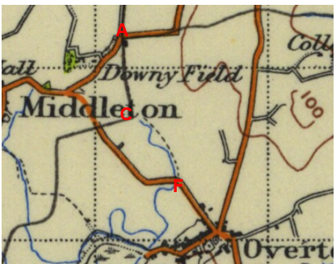
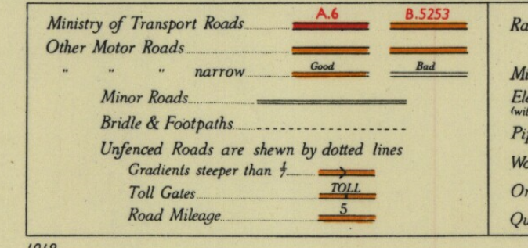
Observations |  | The application route is shown on the map denoted by a dashed line which was indicated as being a footpath or bridleway in the map key.
Investigating Officer's Comments |  | The application route existed in the 1920s and appeared to have been considered to be a footpath or bridleway.
1:25,000 OS Map  Sheet 34/45 | 1947 | Further OS map extract provided by the applicant. Published in 1947 but date of survey not known.
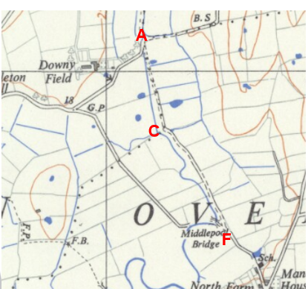
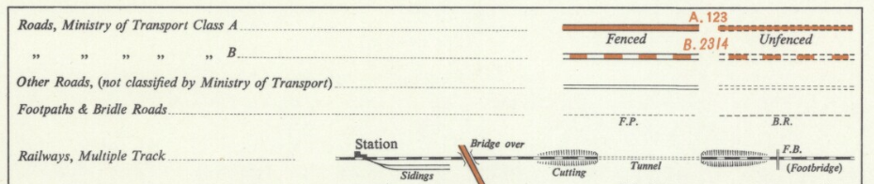
Observations |  | The application route is shown. It appears, with reference to the map key, to be shown as 'other road' as opposed to other routes on the map shown by single dashed lines and denoted as footpaths (FP) and bridleways (BW).
Investigating Officer's Comments |  | The application route existed in the 1940s. Its physical appearance as a partially enclosed track may have been the reason why it was shown as 'other road'. As with all OS maps examined the OS disclaimer indicated that the showing of a route as a footpath, bridleway or road was not indicative of its public status.
6 Inch OS Map  Map 45NW | 1955 | The OS base map for the Definitive Map, First Review, was published in 1955 at a scale of 6 inches to 1 mile (1:10,560). This map was revised before 1930 and is probably based on the same survey as the 1930s 25-inch map.
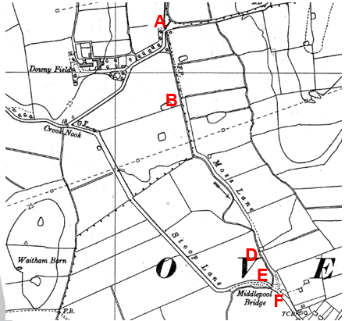
Observations |  | The application route is shown in the same way that it is shown on the earlier OS maps examined.
Investigating Officer's Comments |  | The application route existed in the 1920s and appeared to be capable of being used at least on foot.
1:25,000 OS  Map SD 45 | 1966 | OS map revised 1910-1965 and published 1966.
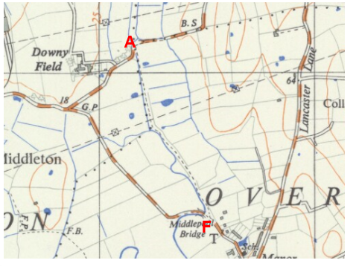
Observations |  | The application route is shown as a single dashed line.
Investigating Officer's Comments |  | The application route existed in the 1960s and appeared to be capable of being used, at least on foot.
1:2500 OS Map  SD 42-58 – 43-58 | 1972 | Further edition of 25 inch map reconstituted from former county series and revised in 1970 and published 1972 as national grid series.
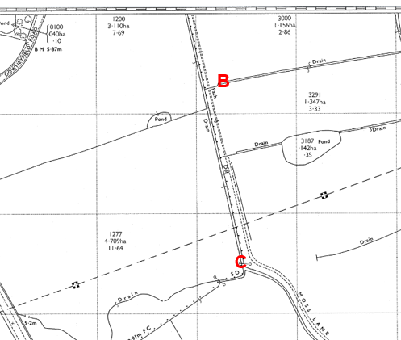
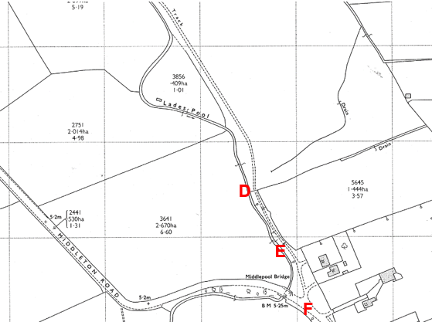
Observations |  | The OS map sheet showing the start of the route from point A could not be found. However at route marked as a 'path' is shown leading from the direction of point A to point B on the lower sheet. A line is shown across the route at point B and also 65 metres south south east of point B from where the route is then shown as a 'track' and also labelled as Moss Lane. A further line is shown across the route at point D and between point E and point F the route now provides access to two residential properties both accessed via point F.
Investigating Officer's Comments |  | The application route existed in the early 1970s and appeared capable of being used at least on foot but there were more structures across the route – it is suggested that it is more likely that these were gates because the formerly enclosed route was more likely to have been used for access to those fields with animals and this is consistent with what is observed today.
Aerial photograph | 1960s | The black and white aerial photograph taken in the 1960s and available to view on GIS.
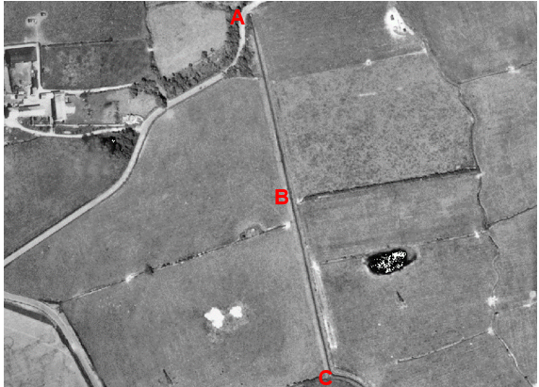
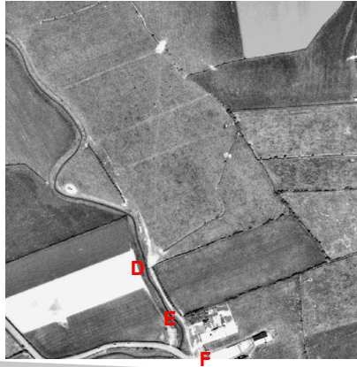
Observations |  | Parts route can be seen as a worn track on the photograph – particularly the southern section between points D-E-F. Traces of a more substantial bounded route that existed in the past appear visible between point B and point C.
Investigating Officer's Comments |  | The land crossed by the application route appears to be accessible with traces of a path in places suggestive of low levels of pedestrian use. The southern end of the route appears to have been used more frequently with vehicles – or possibly by animals – gaining access to the fields.
Aerial Photograph | 2016 | Aerial photograph available to view on GIS.
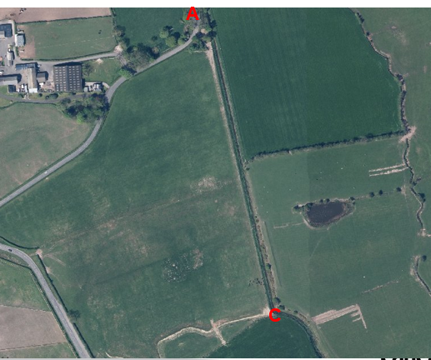
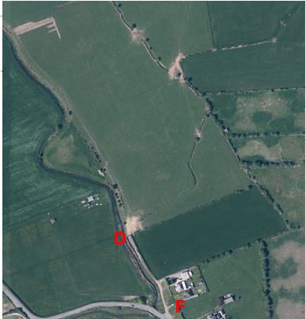
Observations |  | A faint trodden track appears visible along parts of the route from point A through to point B suggestive of low levels of pedestrian use. From point D through to point F the route is much more visible as a track used by vehicles to access properties and fields.
Investigating Officer's Comments |  | The application route existed in 2016 and appeared capable of being used on foot throughout its full length with evidence of vehicular use over the southern section between point D to point F.
Definitive Map Records |  | The National Parks and Access to the Countryside Act 1949 required the County Council to prepare a Definitive Map and Statement of Public Rights of Way.  Records were searched in the Lancashire Records Office to find any correspondence concerning the preparation of the Definitive Map in the early 1950s.
Parish Survey Map | 1950-1952 | The initial survey of public rights of way was carried out by the parish council in those areas formerly comprising a rural district council area and by an urban district or municipal borough council in their respective areas. Following completion of the survey the maps and schedules were submitted to the County Council. In the case of municipal boroughs and urban districts the map and schedule produced, was used, without alteration, as the Draft Map and Statement. In the case of parish council survey maps, the information contained therein was reproduced by the County Council on maps covering the whole of a rural district council area. Survey cards, often containing considerable detail exist for most parishes but not for unparished areas.
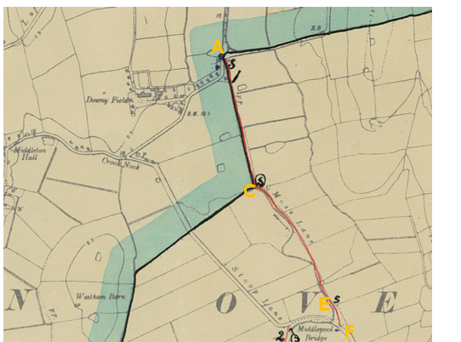
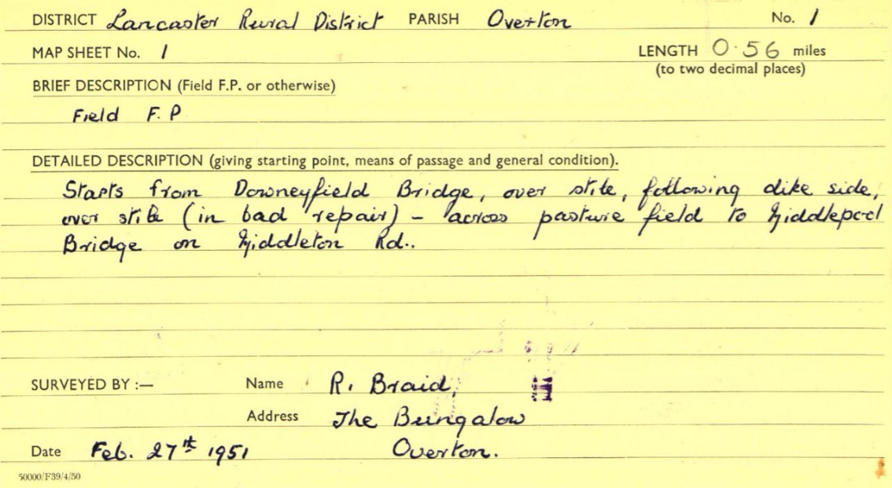
Observations |  | The application route was recorded as a public footpath by Overton Parish council in 1951. The parish survey card produced at that time describes the route as a field footpath.
Draft Map |  | The parish survey map and cards for Overton were handed to Lancashire County Council who then considered the information and prepared the Draft Map and Statement.  The Draft Maps were given a “relevant date” (1st January 1953) and notice was published that the draft map for Lancashire had been prepared. The draft map was placed on deposit for a minimum period of 4 months on 1st January 1955 for the public, including landowners, to inspect them and report any omissions or other mistakes. Hearings were held into these objections, and recommendations made to accept or reject them on the evidence presented.
Observations |  | The application route was recorded as a public footpath on the Draft Map and no objections of representations were made relating to it.
Provisional Map |  | Once all representations relating to the publication of the draft map were resolved, the amended Draft Map became the Provisional Map which was published in 1960, and was available for 28 days for inspection. At this stage, only landowners, lessees and tenants could apply for amendments to the map, but the public could not. Objections by this stage had to be made to the Crown Court.
Observations |  | The application route was recorded as a public footpath on the Provisional Map and no objections of representations were made relating to it.
The First Definitive Map and Statement |  | The Provisional Map, as amended, was published as the Definitive Map in 1962.
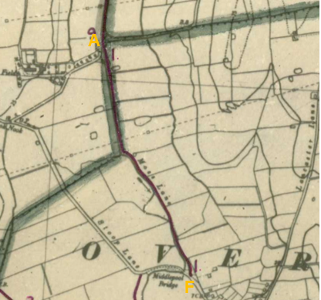
Observations |  | The application route was recorded as a public footpath on the First Definitive Map.
Revised Definitive Map of Public Rights of Way (First Review) |  | Legislation required that the Definitive Map be reviewed, and legal changes such as diversion orders, extinguishment orders and creation orders be incorporated into a Definitive Map First Review. On 25th April 1975 (except in small areas of the County) the Revised Definitive Map of Public Rights of Way (First Review) was published with a relevant date of 1st September 1966. No further reviews of the Definitive Map have been carried out. However, since the coming into operation of the Wildlife and Countryside Act 1981, the Definitive Map has been subject to a continuous review process.
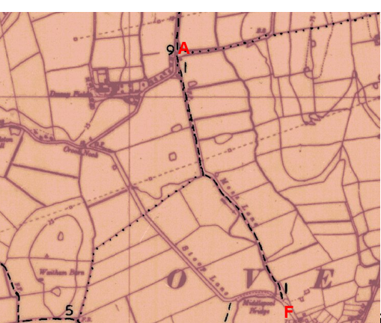
Observations |  | The application route is recorded as a public footpath on the Revised Definitive Map (First Review).
Investigating Officer's Comments |  | The application route was considered to be a footpath during the preparation of the First Definitive Map and Statement in the 1950s through to the 1960s.
Highway Adoption Records including maps derived from the '1929 Handover Maps' | 1929 to present day | In 1929 the responsibility for district highways passed from district and borough councils to the County Council. For the purposes of the transfer, public highway 'handover' maps were drawn up to identify all of the public highways within the county. These were based on existing Ordnance Survey maps and edited to mark those routes that were public. However, they suffered from several flaws – most particularly, if a right of way was not surfaced it was often not recorded.  A right of way marked on the map is good evidence but many public highways that existed both before and after the handover are not marked. In addition, the handover maps did not have the benefit of any sort of public consultation or scrutiny which may have picked up mistakes or omissions.  The County Council is now required to maintain, under section 31 of the Highways Act 1980, an up to date List of Streets showing which 'streets' are maintained at the public's expense. Whether a road is maintainable at public expense or not does not determine whether it is a highway or not.
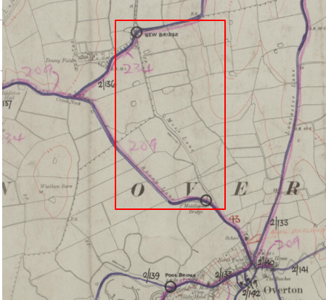
Observations |  | The application route is not recorded as a publicly maintainable highway on the county council's List of Streets and was not shown as a publicly maintainable highway in the records believed to be derived from the 1929 Handover Map. The route is a publicly maintained footpath which is on the Definitive Map and Statement of Public Rights of Way.
Investigating Officer's Comments |  | The fact that the route is not recorded as a publicly maintainable highway on the List of Streets does not mean that it does not carry public rights of access other than those rights currently recorded on the Definitive Map.
Highway Stopping Up Orders | 1835 - 2014 | Details of diversion and stopping up orders made by the Justices of the Peace and later by the Magistrates Court are held at the County Records Office from 1835 through to the 1960s. Further records held at the County Records Office contain highway orders made by Districts and the County Council since that date.
Observations |  | No records relating to the stopping up, diverting or creation of public rights along the route were found.
Investigating Officer's Comments |  | If any unrecorded rights exist along the route they do not appear to have been stopped up or diverted.
Statutory deposit and declaration made under section 31(6) Highways Act 1980 |  | The owner of land may at any time deposit with the County Council a map and statement indicating what (if any) ways over the land he admits to having been dedicated as highways. A statutory declaration may then be made by that landowner or by his successors in title within ten years from the date of the deposit (or within ten years from the date on which any previous declaration was last lodged) affording protection to a landowner against a claim being made for a public right of way on the basis of future use (always provided that there is no other evidence of an intention to dedicate a public right of way).  Depositing a map, statement and declaration does not take away any rights which have already been established through past use. However, depositing the documents will immediately fix a point at which any unacknowledged rights are brought into question. The onus will then be on anyone claiming that a right of way exists to demonstrate that it has already been established. Under deemed statutory dedication the 20 year period would thus be counted back from the date of the declaration (or from any earlier act that effectively brought the status of the route into question).
Observations |  | No Highways Act 1980 Section 31(6) deposits have been lodged with the county council for the area over which the application route runs.
Investigating Officer's Comments |  | There is no indication by the landowners under this provision of non-intention to dedicate public rights of way over this land.

The affected land is not designated as access land under the Countryside and Rights of Way Act 2000 and is not registered common land.

The Natural Environment and Rural Communities Act 2006

This Act effected a blanket extinguishment of unrecorded public rights for mechanically propelled vehicles (MPVs) with certain exceptions. Prior to this carriageway rights did not discriminate between vehicles which were mechanically propelled, such as cars and motorbikes, and those which were not, such as bicycles, wheelbarrows, horse-drawn carriages, donkey carts, etc.. If Committee concludes that the evidence shows that, on the balance of probability, public carriageway rights exist along the application route it is then necessary to consider whether the Natural Environment and Rural Communities Act 2006 has extinguished public rights for MPVs. The application route was, at the time of the act recorded as a public footpath and was not on the List of Streets (maintained at public expenses) and it does not appear to have been used mainly by the public in MPVs. There is no claim that any other of the other exemptions apply. Therefore, if public carriageway rights are shown to exist and the appropriate status for the application route to be recorded on the Definitive Map and Statement would be Restricted Byway, with public rights with non-mechanically propelled vehicles, horses or on foot.

Landownership

From point A to point D the application route crosses title LAN107739 from point D to point F the application route crosses land which is unregistered.

Summary

It is rare to find one single piece of map or documentary evidence which is strong enough to conclude that public rights exist and it is usually the case that we need to examine a body of evidence, often spanning a substantial period of time, from which public rights can be inferred.

In conclusion, a range of commercial maps and other documents were examined which seem to suggest that the application route existed in its entirety as a through-route from the late 1700s or early 1800s. The early commercial maps - Yates' Map of 1786, Greenwood's Map of 1818 and Hennet's Map of 1830 all consistently show the route as a cross road and the inclusion of the route on all three maps suggests that in the mid-1700s through to at least 1830 the route appeared to form part of the public vehicular highway network.

This view is given further weight by the fact that the full length of the route is recorded as a public road owned by the Surveyors of the Highway on the Overton Tithe Map produced in 1844. In addition, on the Middleton Tithe Map 1844 the northern section of the application route between point A and point C is also listed in the Apportionment as owned by the Surveyors of the Highways and described as a 'lane'. Also, on the Heaton with Oxcliffe Tithe Map, prepared several years earlier in 1841, the start of the route at point A is shown and is labelled “from Overton” suggesting that it was considered to be a public vehicular route from Overton.
The application route is clearly shown on the first edition 6 inch OS map published in 1848 and is labelled as part of Moss Lane.

However, by the late 1800s it appears from the map evidence available, that use of the route declined in favour of using the route along Downeyfield Road and Middleton Road. No legal Orders have been found extinguishing public rights along the application route and it is suggested that whilst Downeyfield Road and Middleton Road may have been repaired and maintained, the application route, which ran adjacent to a watercourse and was potentially wet and boggy underfoot simply fell out of use by people travelling by horse or with horses and carts.

Ordnance Survey maps from the late 1800s onwards show gates across the route and the fact that it appeared to become somewhat overgrown. Over time boundaries separating the route from the adjacent fields were removed and the route –whilst still named as Moss Lane was also labelled as a path and track.

By the 1950s when the parish survey was carried out as part of the preparation of the Definitive Map the route was described as a field footpath and recorded as a public footpath. This appears to be consistent with the use made of the route at that time but does not reflect the historical use of the route as a public road.

Head of Service – Legal and Democratic Services Observations

Information from the Applicant

The applicant provided copies of the following maps and documents in support of the application:
Yates' Map of Lancashire 1788
Greenwood's Map of Lancashire 1818
Hennet's Map of Lancashire 1830
6 inch OS maps published in 1848, 1895 and 1916
25 inch OS maps published in 1891 and 1913
1 inch OS maps published in 1898, 1918 and 1947
1:25,000 OS maps published in 1947 and 1966
Overton Tithe Map and Award 1844
Middleton Tithe Map and Award 1844
Heaton with Oxcliffe Tithe Map 1841
Finance Act Map 1910
Land ownership information obtained from the land registry
Lancashire county council List of Streets
Search of stopping up orders from the London Gazette
Recent (2020) photographs of the route

Information from Others

One of the adjoining landowners responded to confirm the land in their ownership with a request for a clarification of the DMMO process. This information was provided.

The local Cycling UK Right to Ride representative responded to our consultation to state that they had no objection to the application.

Atkins Global responded to our consultation to state that they had no objection to the application.

We received communication from Thomas Hayton Winkley Solicitors on behalf of an affected party requesting further information regarding the application and details of how to submit evidence pertinent to the application. Despite this, no further submission has been received.

Information from the Landowner

Representatives acting on behalf of the owner of the field crossed by the application route between point A and point B responded to the consultation objecting to the application.

They explained that the landowning family purchased the field in 1966 and the route had not been used as a bridleway since that time. In addition, they refer to work carried out by the Water Board between 1932 and 1966 to widen the watercourse running alongside the application route. In their opinion the work carried out took a strip of land approximately 12 foot wide from the western side of the field including the land they described as being the 'old road' and they now consider that the old route no longer physically exists.

In addition, they express concerns about gates being left open and livestock escaping.

The owner of the land between points B-E responded to the consultation stating strong opposition to the application.

They went on to state that in their opinion there was no sign of the route ever having been a lane, just an open field with the footpath running down the side.

Concerns raised related to the use of the field for grazing cattle, the landowner believing that if the application is successful use as a bridleway will lead to gates being left open.

It was noted that on occasion the landowner had to lock the gate accessing the field to prevent access by illegal poachers driving vehicles around the field and shooting the wild hare population.

The landowner also noted sheep handling pens on the application route and that use as a bridleway would cause great inconvenience.

Assessment of the Evidence

The Law - See Annex 'A'

In Support of Making an Order(s)

Consistently shown as a cross road on three key early commercial maps suggesting that it existed as part of the public vehicular network until at least the mid 1800s.

Tithe Map and Award evidence from 1844 of the route being considered to be a public road.

Substantial map and documentary evidence supporting the physical existence of the route with an acknowledgement that use as a public vehicular route had declined by the late 1800s.

Against Making an Order(s)

No evidence against making the order

Conclusion

As there is no express dedication and no modern or historical public user evidence has been submitted in these circumstances a presumption of dedication of a public right of way under section 31 cannot be relied upon. It is therefore necessary for Committee to consider whether the map and/or documentary evidence is sufficient to support the dedication of a public right of way under common law.

In this case the route marked A-F is currently recorded as a footpath. The applicant applied for the route to be upgraded to a bridleway but it should be noted that as always Officers from the Planning and Environment Group consider what rights the available map and documentary evidence shows rather than whether or not it supports a particular status.

The evidence presented in this report is sufficiently strong to suggest that a public vehicular route historically connected two other public vehicular highways.

Yates, Greenwood and Hennet each depict the route as a "cross road" which suggest the route in the late 1700's / early 1800's was a substantive route, forming part of the public vehicular network, although it should be noted that Hennet showed the route drawn narrower than other adjacent routes. Further evidence to support the view that the route formed part of the public vehicular network is also reflected in the fact that the full length of the route is recorded as a public road owned by the Surveyors of the Highway on the Overton Tithe Map produced in 1844, and that it was later considered significant enough to be named on the first 6 inch OS Map 1848 as part of "Moss Lane" (although private roads can be named too).

Subsequent editions of the OS maps appear to reflect that use of the route for some reason had declined by the late 1800's and gates appear to be shown at various points along the route. The possible presence of gates across the route by the OS is not inconsistent with a public route in a rural area and the route appears to be depicted in such a way that it appears to have been capable of being used on horseback.

The representations made by the Parish Council and landowner concerning the practical issues are, of course, important but they are not relevant to the issue of what public rights already exist in law. These concerns raised may, however, be addressed by the future management of the route should an Order be made and confirmed.

A comparison of the modern day field boundaries and position of the watercourse adjacent to the route between point A and point B with what is shown on the First Edition 25 inch OS map indicates that the watercourse remains the same although the sloping banking has been extended. However there is still a lot of the width of the old road/application route which has been incorporated into the modern field and even if the historical width was 'lost' onto the sloping bank it would still not affect the assessment of documentary evidence.

In conclusion, there is no single document which offers irrefutable evidence in its own right to determine this application. Collectively, there is a large body of evidence which supports the physical existence of the route from points A to D since at least 1786 and of it being capable of being used on foot, horseback and by vehicles into the 19th Century. The evidence suggests that historically the route formed part of the public vehicular network but that over time alternative vehicular routes were used.

If Committee is content that there is sufficient evidence of a vehicular highway along the application route then the Natural Environment and Rural Communities Act 2006 will have extinguished modern mechanically propelled vehicular rights leaving the route to be appropriately recorded as a restricted byway.

It is therefore recommended to make an Order as set out in the Recommendation at the beginning of the report and that it be promoted to confirmation.

Risk management

Consideration has been given to the risk management implications associated with this claim. The Committee is advised that the decision taken must be based solely on the evidence contained within the report, and on the guidance contained both in the report and within Annex 'A' included in the Agenda Papers. Provided any decision is taken strictly in accordance with the above then there are no significant risks associated with the decision making process.

Local Government (Access to Information) Act 1985

List of Background Papers

Paper | Date | Contact/Directorate/Tel
All documents on File Ref: 804-653 |  | Simon Moore, 01772 531280, County Secretary and Solicitors Group
Reason for inclusion in Part II, if appropriate

N/A

The Ordnance Survey (OS) has produced topographic maps at different scales (historically one inch to one mile, six inches to one mile and 1:2500 scale which is approximately 25 inches to one mile). Ordnance Survey mapping began in Lancashire in the late 1830s with the 6-inch maps being published in the 1840s. The large scale 25-inch maps which were first published in the 1890s provide good evidence of the position of routes at the time of survey and of the position of buildings and other structures. They generally do not provide evidence of the legal status of routes, and carry a disclaimer that the depiction of a path or track is no evidence of the existence of a public right of way.

